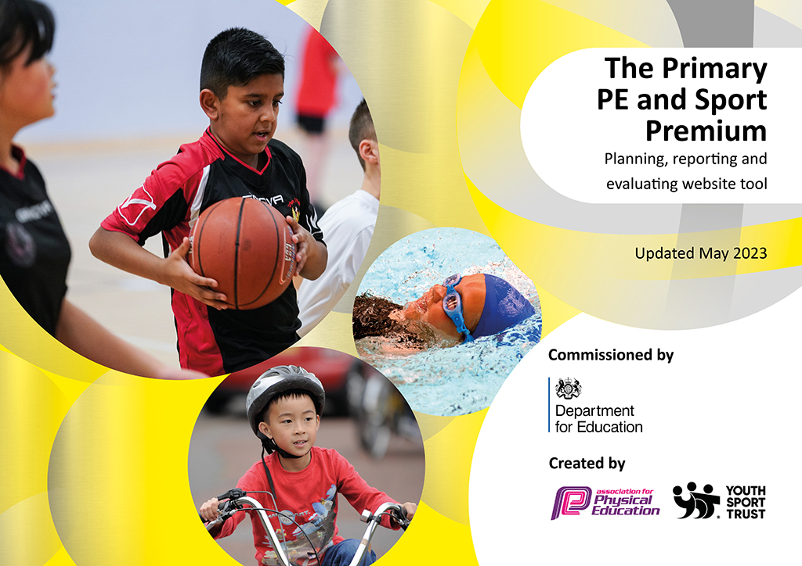
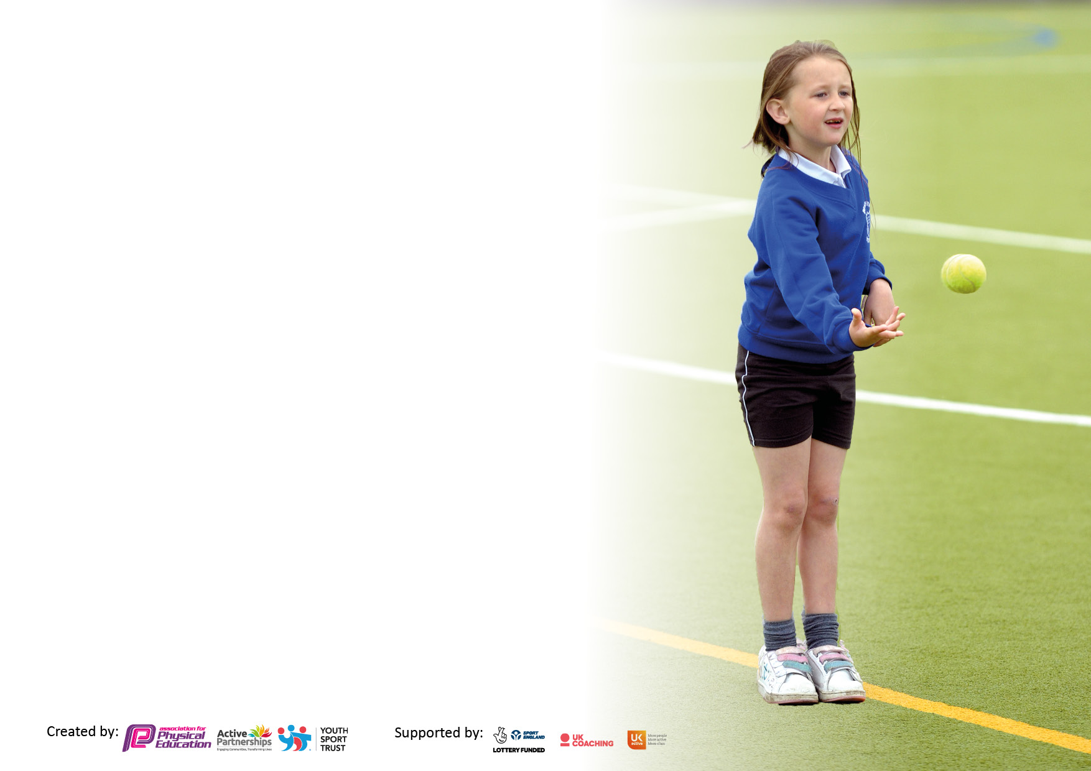

It is important that your grant is used effectively and based on school need. The Education Inspection Framework makes clear there will be a focus on ‘whether leaders and those responsible for governors all understand their respective roles and perform these in a way that enhances the effectiveness of the school’.

Under the Quality of Education Ofsted inspectors consider:
Intent - Curriculum design, coverage and appropriateness
Implementation - Curriculum delivery, Teaching (pedagogy) and Assessment
Impact - Attainment and progress

To assist schools with common transferable language this template has been developed to utilise the same three headings which should make your plans easily transferable between working documents.

Schools must use the funding to make additional and sustainable improvements to the quality of Physical Education, School Sport and Physical Activity (PESSPA) they offer. This means that you should use the Primary PE and sport premium to:

- Develop or add to the PESSPA activities that your school already offer
- Build capacity and capability within the school to ensure that improvements made now will benefit pupils joining the school in future years
- The Primary PE and sport premium should not be used to fund capital spend projects; the school’s budget should fund these.

Please visit gov.uk for the revised DfE guidance including the5keyindicatorsacrosswhichschoolsshoulddemonstrate an improvement. This document will helpyoutoreviewyourprovisionandtoreportyourspend.DfEencouragesschools to use this template as an effective way of meeting the reporting requirements of the Primary PE and Sport Premium.

We recommend you start by reflecting on the impact of current provision and reviewing the previous spend.

Schools are required to publish details of how they spend this funding, including any under-spend from 2021/2022, as well as on the impact it has on pupils’ PE and sport participation and attainment. The funding should be spent by 31st July but the DfE has stated that there will be no clawback of any unspent money so this can be carried forward into 2023/24.

We recommend regularly updating the table and publishing it on your website throughout the year. This evidences your ongoing self-evaluation of how you are using the funding to secure maximum, sustainable impact. Final copy must be posted on your website by the end of the academic year and no later than the 31st July 2023. To see an example of how to complete the table please click HERE.

Details with regard to funding
Please complete the table below.

Total amount carried over from 2021/22 | £0
Total amount allocated for 2021/22 | £19510
How much (if any) do you intend to carry over from this total fund into 2022/23? | £0
Total amount allocated for 2022/23 | £19490
Total amount of funding for 2022/23. Ideally should be spent and reported on by 31st July 2023. | £19490
Swimming Data
Please report on your Swimming Data below.

Meeting national curriculum requirements for swimming and water safety.  N.B. Complete this section to your best ability. For example you might have practised safe self-rescue techniques on dry land which you can then transfer to the pool when school swimming restarts.  Due to exceptional circumstances priority should be given to ensuring that pupils can perform safe self rescue even if they do not fully meet the first two requirements of the NC programme of study | 64%
What percentage of your current Year 6 cohort swim competently, confidently and proficiently over a distance of at least 25 metres?  N.B. Even though your pupils may swim in another year please report on their attainment on leaving primary school at the end of the summer term 2023.  Please see note above | 57%
What percentage of your current Year 6 cohort use a range of strokes effectively [for example, front crawl, backstroke and breaststroke]?  Please see note above | 57%
What percentage of your current Year 6 cohort perform safe self-rescue in different water-based situations? | 87%
Schools can choose to use the Primary PE and sport premium to provide additional provision for swimming but this must be for activity over and above the national curriculum requirements. Have you used it in this way? | No

Action Plan and Budget Tracking
Capture your intended annual spend against the 5 key indicators. Clarify the success criteria and evidence of impact that you intend to measure to evaluate for pupils today and for the future.

Academic Year: 2022/23 | Total fund allocated: | Date Updated:
Key indicator 1: The engagement of all pupils in regular physical activity – Chief Medical Officers guidelines recommend that primary school pupils undertake at least 30 minutes of physical activity a day in school |  |  |  | Percentage of total allocation:
 |  |  |  | %
Intent | Implementation |  | Impact
Your school focus should be clear what you want the pupils to know and be able to do and about  what they need to learn and to  consolidate through practice: | Make sure your actions to achieve are linked to your intentions: | Funding allocated: | Evidence of impact: what do pupils now know and what can they now do? What has changed?: | Sustainability and suggested next steps:
All children to participate in 2 hours of PE every week.  To engage children in PA and SS during unstructured times of the day (e.g. lunch times) above and beyond their usual 2 hours of PE. | All staff across school to have access to the Create Learning Platform (Real PE) with planning and resources available.  School have purchased a range of lunch time equipment to provide more opportunity for PA and SS during unstructured times of the day (i.e. lunch times). | £695 | All children have access to 2 hours of PE every week.  Staff are monitoring progress through the use of assessment wheels for the fundamental movement skills and learning behaviours.  Staff are accessing platform for planning and resources every week to deliver high quality PE lessons.  Children will show more engagement during unstructured times and will have a higher emphasis on PA and SS during these times. This will also have a positive effect on behaviour management during these unstructured times. | Continue to deliver 2 hours of PE every week.  Train Real Leaders (in KS2) to support with the delivery of lunch time activities to ensure physical activity is taking part during both structured and unstructured times.  Provide CPD opportunities for lunch time supervisors to encourage more engagement of PA and SS during lunch times.
Key indicator 2: The profile of PESSPA being raised across the school as a tool for whole school improvement |  |  |  | Percentage of total allocation:
 |  |  |  | %
Intent | Implementation |  | Impact
Your school focus should be clear what you want the pupils to know and be able to do and about  what they need to learn and to  consolidate through practice: | Make sure your actions to achieve are linked to your intentions: | Funding allocated: | Evidence of impact: what do pupils now know and what can they now do? What has changed?: | Sustainability and suggested next steps:
All staff trained in Real PE and following the scheme weekly.  External providers brought into school to support with SP. | All staff deliver 2 hours of PE to children weekly following Real PE.  PE is assessed half termly using assessment wheels to ensure that children are making progress in PE.  Children attend after school provision provided by external providers to ensure that healthy competition is encouraged. | £1215 | All children partake in 2 hours of PE every week (class teachers are accessing learning platform).  PE is assessed by class teacher’s half termly (fundamental movement skills and learning behaviours).  More children have engaged with a club after school where they compete regularly. | Class teachers are more confident at delivering PE.  Class teachers to have more CPD around assessment and what to look for.  Real Leaders to be implemented into KS2 to provide more opportunity for PA at unstructured times.

Key indicator 3: Increased confidence, knowledge and skills of all staff in teaching PE and sport |  |  |  | Percentage of total allocation:
 |  |  |  | %
Intent | Implementation |  | Impact
Your school focus should be clear | Make sure your actions to | Funding | Evidence of impact: what do | Sustainability and suggested
what you want the pupils to know | achieve are linked to your | allocated: | pupils now know and what | next steps:
and be able to do and about | intentions: |  | can they now do? What has
what they need to learn and to |  |  | changed?:
consolidate through practice:
All staff trained in Real PE and following the scheme weekly.  CPD opportunities for staff in the delivery of Real PE. | All staff access Jasmine Learning Platform regularly to deliver 2 hours of PE each week.  Subject leader communicates with Create Development for support in leading PE and supporting other staff.  New staff provided training to ensure that all teachers are confident to follow scheme.  Staff meetings on Real PE provided by subject leader. | Cost of Create Learning platform (already allocated) | Subject leader is up to date on all knowledge related to Real PE.  Subject leader is confident in supporting other staff members with the scheme.  All staff have received basic training on using Real PE to deliver 2 hours of PE every week.  All staff can assess using assessment wheels half termly. | All staff to continue to deliver 2 hours of PE every week.  Create development to work with Subject leader to implement other areas such as Real Leaders, Real Gym and Real Dance.
Key indicator 4: Broader experience of a range of sports and activities offered to all pupils |  |  |  | Percentage of total allocation:
Intent | Implementation |  | Impact
Your school focus should be clear | Make sure your actions to | Funding | Evidence of impact: what do | Sustainability and suggested
what you want the pupils to know | achieve are linked to your | allocated: | pupils now know and what | next steps:
and be able to do and about | intentions: |  | can they now do? What has
what they need to learn and to |  |  | changed?:
consolidate through practice:
Plan and deliver a broad range of extra-curricular activities.  Purchase equipment needed to ensure a broad range of activities can take place.  External providers brought into school to assist in the training of the football team. | Subject leader to plan a time table for extra curricular activities.  Offering a wide range of activities will increase the number of children participating in a variety of sporting opportunities.  Purchasing more equipment will allow more children to engage regularly in PE, SS and PA and access a broader range of activities.  External providers will support the school in ensuring a high-quality provision is provided in football to ensure that children are given the opportunity to compete with a strong understanding of the sport. | £492.22 | More children have engaged in extra curricular activities across school.  More clubs are able to be delivered with the new equipment purchased.  Children have a better understanding of football through the external providers and are able to compete at a competitive level in different leagues. | Continue to provide a healthy varied extracurricular time table across the year.  Ensure equipment is well maintained and up to date in line with the delivery of Real PE and SS.  Children to continue to compete at a competitive level.  Target children to participate in a range of opportunities through school games.

Key indicator 5: Increased participation in competitive sport |  |  |  | Percentage of total allocation:
 |  |  |  | %
Intent | Implementation |  | Impact
Your school focus should be clear | Make sure your actions to | Funding | Evidence of impact: what do | Sustainability and suggested
what you want the pupils to know | achieve are linked to your | allocated: | pupils now know and what | next steps:
and be able to do and about | intentions: |  | can they now do? What has
what they need to learn and to |  |  | changed?:
consolidate through practice:
Compete in the Forge Trust League Championship.  Compete in the Bassetlaw football league.  To put on a competitive sports day for KS1 and KS2.  Purchase new equipment for the hosting of competitive fixtures across different sports (i.e. football, netball, basketball). | Children in Y5 and Y6 represented our school in the Forge Trust league championship and Bassetlaw football league where they competed against other schools in football.  Ensure transport was provided to meet the attendance needs of these events.  All children in KS1 and KS2 took part in sports day.  Having the correct equipment will allow school to host more competitive events and fixtures in the area and leagues ensuring more competitive opportunities in different sports. | £300  £10,787.87 | Children’s confidence has grown when competing competitively.  Children learning healthy competition through sports day.  Children engage competitively in different football leagues using the correct equipment. School is able to be more involved in local community through hosting competitions and games. | Join the local area school games and attend sporting events in the area.  Continue to compete in different football leagues to ensure children experience competition at different levels.  Continue to ensure all children access a sports day and learn healthy competition.  Join competitive leagues in a wider range of sports (e.g. Netball). Increase participation in a wider range of sports.

£6000 to be carried over into 2023/24 academic year due to flooding in the school impacting PE, SS and PA during 2022/23.
Signed off by Mark Nunn
Head Teacher: | Stephen Houghton
Date: | 27.07.2023
Subject Leader: | Karl Bower
Date: | 27.07.2023
Governor: | Mark Nunn (Executive Principal)
Date: | 27.07.23

